**DIGITAL SIGNAL PROCESSING LAB**

**Lab sheet. No: 05**

**NAME: NIKHIL KILARI Roll. No: EE16B017**

**Prelab:**

**Question 1**

**Aim:**

To use MATLAB to plot pole-zero map of the given signal and list the possible ROC’s for left sided, right sided and two sided signal

**Short Theory;**

We use zplane function to plot the pole-zero plot of the given signal.

**Key Commands:**

* zplane()

**Results:**

**For first X(z)**

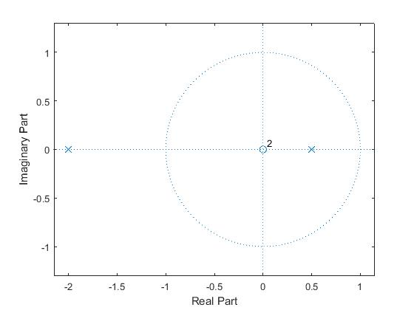

**For second X(z)**

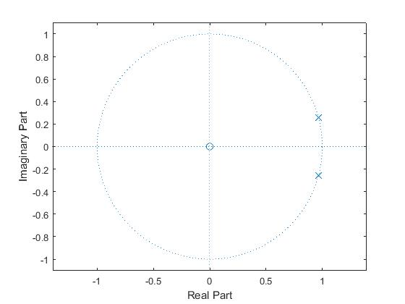

**Comments/Inferences:**

For first X(z) the ROC’s re as follows:

* Left sided function : |z|<0.5
* Two sided function : 0.5<=|z|<=2
* Right sided function: |z|>2

For second X(z) the ROC’s are as follows:

* Left side function: |z|<1
* Right sided function: |z|>1
* Two sided function: Does not exist

**Question 2**

**Aim:**

* To find H(z) and find the region of convergence.
* To write the difference equation satisfied by the given input and output and to find whether the system is stable or casual or both.

**Short Theory:**

The z transform of anu[n] is 1/(z-a)

**Key Commands:**

* zplane()

**Results:**

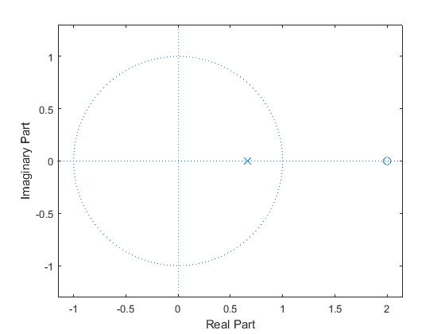

**Comments/Inference:**

* The difference equation is y[n]-0.66y [n-1] = x[n]-2x [n-1].
* The ROC is |z|>0.666
* The system is both stable and causal

**Lab Exercises:**

**Question 1**

**Aim:**

* To find the impulse response of the difference equation using impz function.
* To modify the program to generate the first 40 samples of the impulse response of the given difference equation.
* To generate the impulse response of the system using filter function for the first 40 samples and compare the response with previous response
* To write matlab program to generate the step response for the first 40 samples

**Short Theory:**

1. By giving the numerator and denominator coefficients to the impz function we get the impulse response of the transfer function.
2. By mention the number of samples in the impz function we get impulse response based on the number of samples specified
3. In filter command by mentioning the transfer coefficients and the function to which the function is to be applied we get the output
4. By using conv function we find the output of unit step signal and impulse response.

**Key Commands:**

* impz(b,a,50)
* filter(b,a,x)
* conv(u,v)

**Result:**

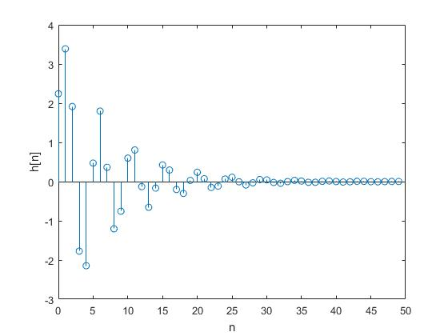

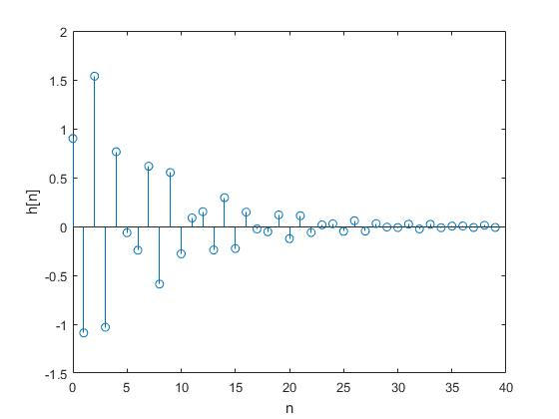

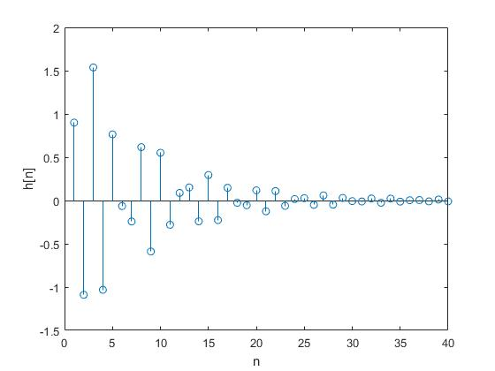

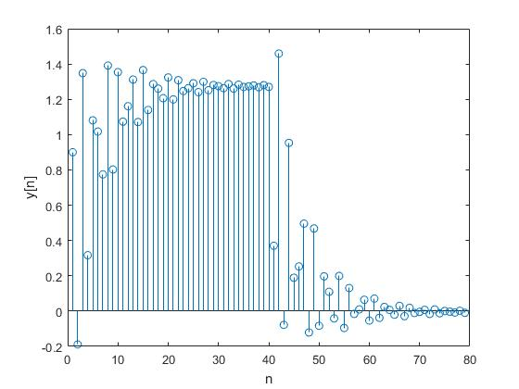

**Inferences/comments:**

* We therefore find that the response of 1b matches exactly as that of 1c.

**Question 2**

**Aim:**

To use ztrans to find z transform of anu[n], and to find inverse z-transform using iztrans to verify the results.

**Short Theory:**

We syms to declare n a and z as variables by doing so we define the function in terms of a and n. Then we apply ztrans and iztrans to verify the results

**Key Commands:**

* y = ztrans(f,z)
* f1 = iztrans(y)

**Results:**

We get

* y = -z/ (a - z)
* piecewise(a == 0, kroneckerDelta(n, 0), a ~= 0, a*(a^n/a - kroneckerDelta(n, 0)/a) +kroneckerDelta(n, 0))

**Comments/Inference:**

We find both f and f1 are the same function

**Question 3**

**Aim:**

To determine X3=X1*X2 For given X1 and X2 and find theoretically find y[n] and verify the results

**Short Theory:**

For given X1 and X2 we find x1[n] and x2[n] and then use conv function to find y[n]. Theoretically we find X3 and then find the inverse z transform to verify the results.

**Key Commands:**

* conv(x1,x2)
* iztrans(f3)

**Results:**

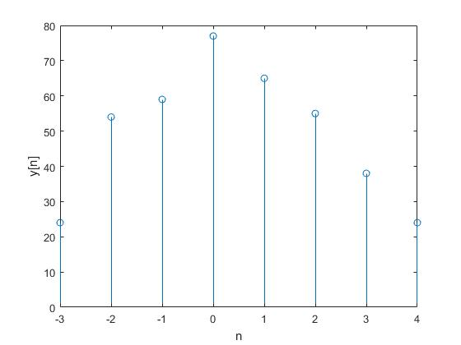

**Comments/Inferences:**

* We find both y[n] and the inverse z transform of X3 are same.

**Question 4**

**Aim:**

* To find the pole zero maps of H(z), X(z) and Y(z)
* Plot impulse response h[n]
* Plot the output signal y[n]

**Short Theory:**

We use zplane(b,a) to plot zero maps of the transfer function. And then we use impz() to find the inverse z transform of the transfer functions

**Key Commands:**

* impz(b,a)
* zplane(b,a)

**Result:**

**Zplane of X**

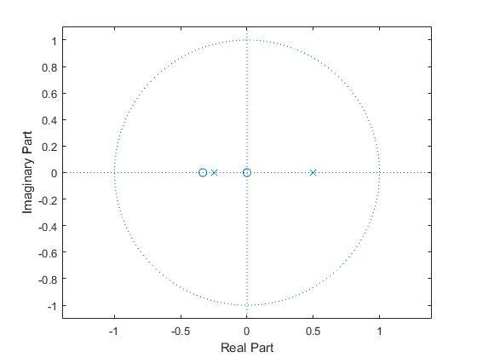

**Zplane of H**

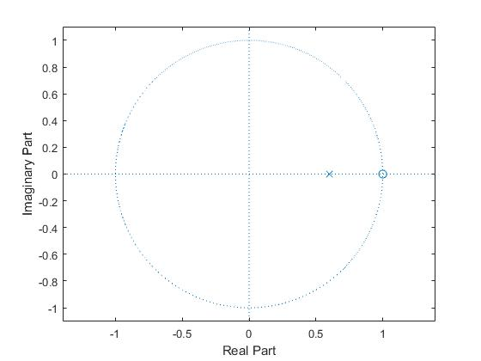

**Zplane of Y**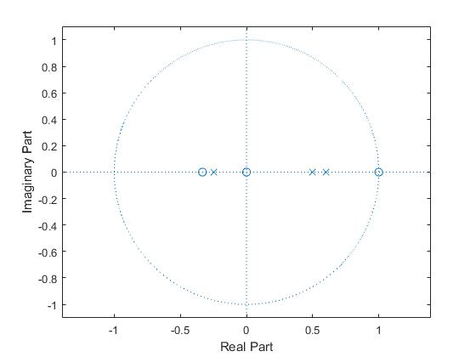

**Impulse Response h[n]**

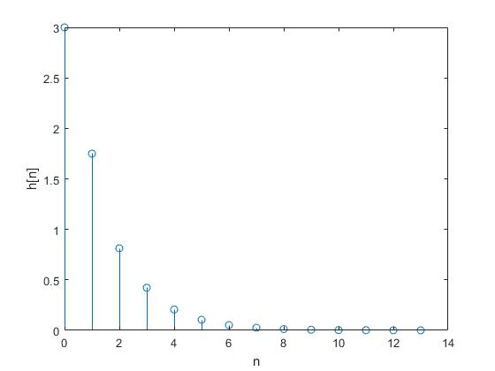

**Output y[n]**

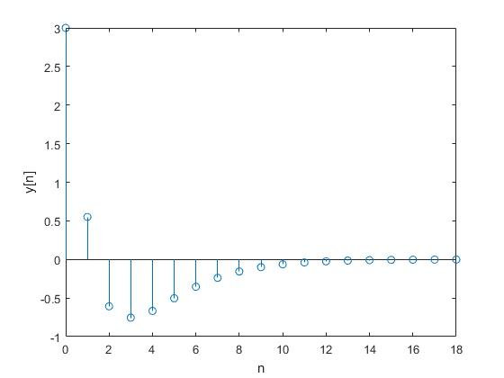

**Comments/Inferences:**

* We find that the Y(z) has the all the poles and zeros of X(z) and H(z).

**Question 5**

**Aim:**

To plot the pole zero map of the transfer function H(z) discussed in prelab(2).

We also need to plot h[n], x[n] and the output signal.

**Short Theory:**

We use impz function to find the signals from transfer function. And use zplane() to plot the pole zero plot of the transfer function.

**Key Commands:**

* impz(b,a)

**Results:**

**Zplane of H(z)**

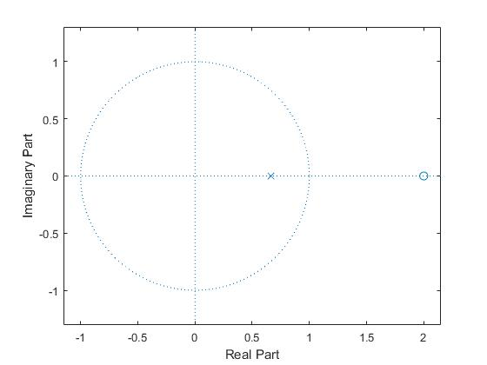

**h[n]**

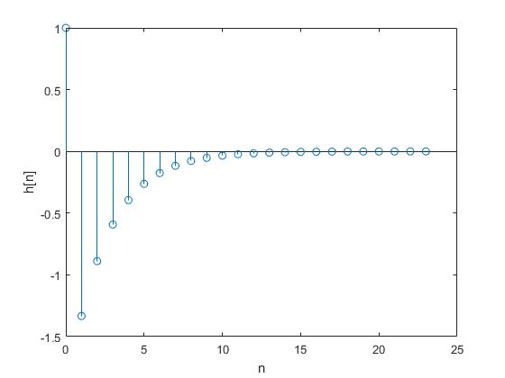

**x[n]**

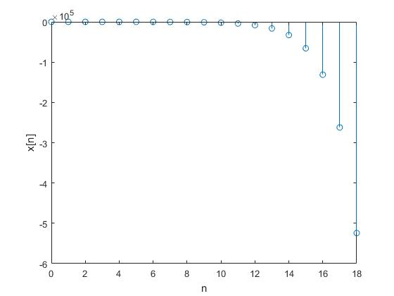

**y[n]**

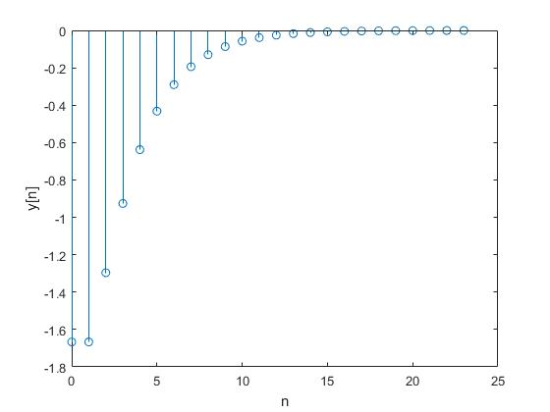

**Comments/Inferences:**

We therefore plot the pole zero plots and the functions successfully.